# Frequently Used

**Controllability**

$$C=\left[\begin{matrix}B & AB & ⋯ & A^{n-1}B\end{matrix}\right], rank\left(C\right)=n$$

**Observability**

$$O={\left[\begin{matrix}C^{⊤} & {\left(CA\right)}^{⊤} & ⋯ & {\left(CA^{n-1}\right)}^{⊤}\end{matrix}\right]}^{⊤}, rank\left(O\right)=n$$

**Algebraic Riccati Equation**

$$P_{∞}=A^{⊤}P_{∞}A+Q-A^{⊤}P_{∞}B{\left(B^{⊤}P_{∞}B+R\right)}^{-1}B^{⊤}P_{∞}A \\ F_{∞}=-{\left(B^{⊤}P_{∞}B+R\right)}^{-1}B^{⊤}P_{∞}A \\ u_{∞}=F_{∞}x\left(k\right)$$

**Lyapunov Function**

$${x_{k+1}}^{⊤}Px_{k+1}-{x_{k}}^{⊤}Px_{k}<-α\left(x\right)$$

**KKT Conditions**

Necessary conditions for optimality are

* Primal Feasibility $g\left(x^{*}\right)≤0$, $h\left(x^{*}\right)=0$
* Dual Feasibility $λ^{*}≥0$
* Complementary Slackness $λ_{i}^{*}g_{i}\left(x^{*}\right)=0$
* Stationarity $∇_{x}L=0$

**Preset**

$$O⊆pre\left(O\right)⇔pre\left(O\right)∩O=O$$

**Minimum Robust Invariant Set**

$$F_{∞}=⊕_{j=0}^{∞}A^{j}W, F_{0}=\left\{0\right\}$$

**Minkowski Operation**

$$\left[a,b\right]⊕\left[c,d\right]=\left[a+c,b+d\right] \\ \left[a,b\right]⊖\left[c,d\right]=\left[a-c,b-d\right]$$

**Stability Assumptions**

* Stage cost is positive definite, i.e. it is strictly positive and only zero at origin.
* Terminal set is invariant under the local control law $κ_{f}\left(x_{i}\right)$:

$$x_{i+1}={Ax}_{i}+Bκ_{f}\left(x_{i}\right)∈X_{f}, ∀x_{i}∈X_{f}$$

All state and input constraints are satisfied in $X_{f}$:

$$X_{f}⊆X, κ_{f}\left(x_{i}\right)∈U, ∀x_{i}∈X_{f}$$

* Terminal cost is continuous Lyapunov function in $X_{f}$ and satisfies:

$$l_{f}\left(x_{i+1}\right)-l_{f}\left(x_{i}\right)≤-l\left(x_{i},κ_{f}\left(x_{i}\right)\right), ∀x_{i}∈X_{f}$$

# Chapter 1 System Theory Basics

## MPC Formulation

$$U_{k}^{*}\left(x\left(k\right)\right)=\underset{U_{k}}{arg min}{l_{f}\left(x_{k+N}\right)+\sum_{i=0}^{N-1}{l\left(x_{k+i},u_{k+i}\right)}}$$

|  |  |
| --- | --- |
| measurement / estimation  system model  state constraints  input constraints  terminal state constraints  optimization variables | $$x_{k}=x\left(k\right)$$ $$x_{k+i+i}=Ax_{k+i}+Bu_{k+i}$$ $$x_{k+i}∈X$$ $$u_{k+i}∈U$$ $$x_{N}∈X_{f}$$ $$U_{k}=\left\{u_{k},⋯,u_{k+N-1}\right\}$$ |

## MPC Advantages

**Constraints:** systematic approach for handling constraints (non-linear dynamics)

**Performance:** high performance controller

## MPC Disadvantages

**Implementation:** MPC problem must be solved in real-time, i.e. within the sampling interval of the system, and with available hardware.

**Feasibility:** Optimization problem may become infeasible at some future time step, i.e. there may not exist a plan satisfying all constraints.

**Stability:** Closed-loop stability, i.e. convergence, is not automatically guaranteed.

**Robustness:** The closed-loop system is not necessarily robust against uncertainties or disturbances.

## Requirement for MPC

model of system; state estimator; define optimal control problem; set up optimization problem; get optimal control sequence; verify closed-loop behavior.

## High Order ODE

$$x_{i+1}=x^{(i)}x, i=0,⋯,n-1 \\ {\dot{x}}_{n}=-g_{n}\left(x_{1},x_{2},⋯,x_{n}\right)$$

## LTI Continuous-Time State-Space Model

$$\dot{x}\left(t\right)=A^{c}x\left(t\right)+B^{c}u\left(t\right) \\ y\left(t\right)=C^{c}x\left(t\right)+D^{c}u\left(t\right)$$

## Exact Solution

$$x\left(t\right)=e^{A^{c}\left(t-t_{0}\right)}x_{0}+\int_{t_{0}}^{t}{e^{A^{c}\left(t-τ\right)}Bu\left(τ\right)dτ}, e^{A^{c}t}=\sum_{n=0}^{∞}{\frac{{\left(A^{c}t\right)}^{n}}{n!}}$$

## Linearization

$$f\left(x,u\right)≈f\left(x_{s},u_{s}\right)+{\left.\frac{∂f}{∂x}\right|}_{\begin{matrix}x=x_{s} \\ u=u_{s}\end{matrix}}\left(x-x_{s}\right)+{\left.\frac{∂f}{∂u}\right|}_{\begin{matrix}x=x_{s} \\ u=u_{s}\end{matrix}}\left(u-u_{s}\right)$$

## Euler Discretization of Linear Time-Invariant Model (Forward Euler)

|  |  |  |
| --- | --- | --- |
| $$x\left(k+1\right)=Ax\left(k\right)+Bu\left(k\right) \\ y\left(k\right)=Cx\left(k\right)+Du\left(k\right)$$ | $$A=I+T_{s}A^{c} \\ B=T_{s}B^{c}$$ | $$C=C^{c} \\ D=D^{c}$$ |

## Exact Discretization of Linear Time-Invariant Model

|  |  |
| --- | --- |
| $$A=e^{A^{c}T_{s}} \\ B=\int_{0}^{T_{s}}{e^{A^{c}\left(T_{s}-τ\right)}B^{c}dτ}={\left(A^{c}\right)}^{-1}\left(A-I\right)B^{c}$$ | $$C=C^{c} \\ D=D^{c}$$ |

*For general nonlinear systems, only approximate discretization exists.*

## Dynamics

$$x\left(k+1\right)=Ax\left(k\right)+Bu\left(k\right) \\ x\left(k+2\right)=A^{2}x\left(k\right)+ABu\left(k\right)+Bu\left(k+1\right) \\ x\left(k+N\right)=A^{N}x\left(k\right)+A^{N-1}Bu\left(k\right)+⋯+ABu\left(k+N-2\right)+Bu\left(k+N-1\right) \\ x\left(k+N\right)=A^{N}x\left(k\right)+\sum_{i=0}^{N-1}{A^{i}Bu\left(k+N-1-i\right)}$$

## Coordinate Transformation

$$\tilde{x}\left(k\right)=Tx\left(k\right), \det\left(T\right)≠0$$

$$T={\left[\begin{matrix}e_{1} & ⋯ & e_{n}\end{matrix}\right]}^{-1}$$

$$\tilde{x}\left(k+1\right)=Λ\tilde{x}\left(k\right)$$

## Stability of Linear System

*For continuous-time LTI system, the asymptotic stability condition is $Re\left(λ_{i}\right)<0$.*

## Controllability (Reachability)

*If the system cannot be controlled to $x^{*}$ in $n$ steps, then it cannot in an arbitrary number of steps.*

## Stabilizability

A system is called stabilizable if there exists an input sequence that returns the state to the origin asymptotically, starting from an arbitrary initial state. A system is stabilizable if and only if all of its uncontrollable modes are stable.

$$rank\left(\left[\begin{matrix}λ_{j}I-A & B\end{matrix}\right]\right)=n, ∀λ_{j}∈Ʌ_{A}^{+}⇒\left(A,B\right) is stabilizable$$

## Obervability $(A,C)$

We only consider a system with zero input for observability.

*Generally, there is an infinite number of choices of the state that yield the same input-output behavior. Observability means, for any possible sequence of state and control, the current state can be determined in finite time using only the outputs.*

## Detectability

A system is called detectable if it possible to construct from the measurement sequence a sequence of state estimates that converges to the true state asymptotically, starting from an arbitrary initial estimate.

$$rank\left(\left[\begin{aligned}A-λ_{j}I \\ C\end{aligned}\right]\right)=n, ∀λ_{j}∈Ʌ_{A}^{+}⇒\left(A,C\right) is detectable$$

## Lyapunov Stability

*Informally, we define a system to be stable in the sense of Lyapunov, if it stays in any arbitrarily small neighborhood of the equilibrium when it is disturbed slightly.*

## Asymptotic Stability

## Lyapunov Indirect Method

*For continuous-time system, the asymptotic stability condition is $Re\left(λ_{i}\right)<0$.*

## Lyapunov Fun**ction**

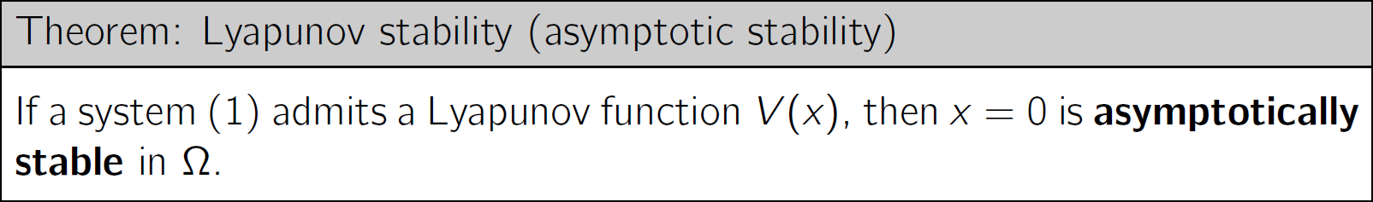

*If is only positive semi-definite, then $x=0$ is a Lyapunov stable point in $Ω$.*

*Level set of Lyapunov function is invariant.*

**ALWAYS REMEMBER TO CHECK THIS CONDITION!**

*The Lyapunov theorems only provide sufficient conditions.*

## LTI Discrete-Time Lyapunov Equation

*For LTI systems, global asymptotic Lyapunov stability is not only sufficient but also necessary. Stability is always “global” for linear systems.*

## Choice of P Matrix

# Chapter 2 Unconstrained Linear Quadratic Optimal Control

## Batch Approach

$$\left[\begin{matrix}x_{0} \\ x_{1} \\ ⋮ \\ ⋮ \\ x_{N}\end{matrix}\right]=\left[\begin{matrix}I \\ A \\ ⋮ \\ ⋮ \\ A^{N}\end{matrix}\right]x\left(0\right)+\left[\begin{matrix}0 & ⋯ & ⋯ & 0 \\ B & 0 & ⋯ & 0 \\ AB & B & ⋯ & 0 \\ ⋮ & ⋱ & ⋱ & ⋮ \\ A^{N-1}B & ⋯ & AB & B\end{matrix}\right]\left[\begin{matrix}u_{0} \\ u_{1} \\ ⋮ \\ ⋮ \\ u_{N-1}\end{matrix}\right]$$

|  |  |
| --- | --- |
| $$X≔S^{x}x\left(0\right)+S^{u}U \\ \overline{Q}≔diag\left(Q,⋯,Q,P\right) \\ \overline{R}≔diag\left(R,⋯,R\right)$$ | $$H≔{\left(S^{u}\right)}^{⊤}\overline{Q}S^{u}+\overline{R} \\ F≔{\left(S^{x}\right)}^{⊤}\overline{Q}S^{u} \\ Y≔{\left(S^{x}\right)}^{⊤}\overline{Q}S^{x}$$ |

$$J\left(x\left(0\right),U\right)=X^{⊤}\overline{Q}X+U^{⊤}\overline{R}U \\ J\left(x\left(0\right),U\right)=U^{⊤}HU+2x{\left(0\right)}^{⊤}FU+x{\left(0\right)}^{⊤}{\left(S^{x}\right)}^{⊤}\overline{Q}S^{x}x\left(0\right) \\ U^{*}\left(x\left(0\right)\right)=-H^{-1}F^{⊤}x\left(0\right) \\ J^{*}\left(x\left(0\right)\right)={x\left(0\right)}^{⊤}\left[{\left(S^{x}\right)}^{⊤}\overline{Q}S^{x}-{\left(S^{x}\right)}^{⊤}\overline{Q}S^{u}{\left({\left(S^{u}\right)}^{⊤}\overline{Q}S^{u}+\overline{R}\right)}^{-1}{\left(S^{u}\right)}^{⊤}\overline{Q}S^{x}\right]x\left(0\right)$$

## Recursive Approach

$$P_{i}=A^{⊤}P_{i+1}A+Q-A^{⊤}P_{i+1}B{\left(B^{⊤}P_{i+1}B+R\right)}^{-1}B^{⊤}P_{i+1}A \\ u_{i}^{*}=-{\left(B^{⊤}P_{i+1}B+R\right)}^{-1}B^{⊤}P_{i+1}Ax_{i}≔F_{i}x_{i} \\ J^{*}\left(x_{k}\right)=x_{k}^{⊤}P_{k}x_{k}$$

## Principle of Optimality

$$J_{j}^{*}\left(x_{j}\right)=\min_{u_{j}}\left\{l\left(x_{i},u_{i}\right)+J_{j+1}^{*}\left(x_{j+1}\right)\right\}$$

## Infinite Horizon LQR

In unconstrained case, infinite-horizon LQR control law $u^{*}\left(k\right)=F_{∞}x\left(k\right)$ is always guaranteed to be asymptotically stable under stability and detectability assumption.

$$F_{∞}=-{\left(B^{⊤}P_{∞}B+R\right)}^{-1}B^{⊤}P_{∞}A \\ J\left(x\left(k\right)\right)={x\left(k\right)}^{⊤}P_{∞}x\left(k\right)$$

## Comparison of Batch Approach and Recursive Approach

Batch optimization returns a sequence $U^{*}\left(x\left(0\right)\right)$ of numeric values depending only on the initial state $x\left(0\right)$, while dynamic programming yields feedback policies $u_{i}^{*}=F_{i}x_{i}$ depending on each $x_{i}$. The recursive solution should be more robust to disturbances and model errors, because if the future states later deviate from their predicted values, the exact optimal input can still be computed.

## Property of $P_{∞}$

If the system is stabilizable and detectable, then the RDE (Riccati Difference Equation) converges to the unique positive define solution $P_{∞}$.

## Lyapunov Function for LQR

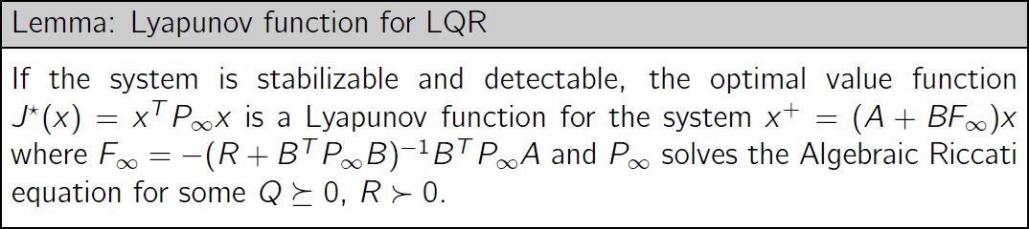

## Choice to Terminal Weight $P$

* The terminal cost $P$ of the finite horizon problem can be chosen so that its solution matches the infinite horizon solution, i.e. $P=P_{∞}$. Choose P assuming no control action after the end of the horizon so that

$$x\left(k+1\right)=Ax\left(k\right)$$

This $P$ can be determined from solving the Lyapunov equation

$$A^{⊤}PA-P=-Q$$

* This approach only make sense if the system is asymptotically stable (or no positive definite solution P will exist).
* Assume we want the state and input both to be zero after the end of the finite horizon. In this case, no $P$ but an extra constraint is needed

$$x_{i+N}=0$$

# Chapter 3: Introduction to Convex Optimization

*Semi-axis lengths are square roots of eigenvalues of $A$.*

## Convex Intersection

The intersection of two of more convex sets is itself convex.

*Vector norms on $R^{n}$ are convex functions.*

## First-Order Condition for Convexity

$$f\left(y\right)≥f\left(x\right)+{∇f\left(x\right)}^{⊤}\left(y-x\right)$$

and domain $X$ is convex.

## Second-Order Condition for Convexity

$$∇^{2}f\left(x\right)≥0$$

and domain $X$ is convex.

## Sub-Level Set Convexity

If the function $f$ is convex, then the sub-level sets of $f$ are convex for all $α$.

## Convexity-Preserving Operations

* Non-negative weighted sum
* composition with affine functions
* pointwise maximum and supremum
* partial minimization

## Convex Optimization Problem

* objective function $f$ and inequality constraint $g$ convex
* domain of $f$ convex
* equality constraint functions affine (convex)

*Feasible set of a convex optimization problem is convex.*

## Optimizer in Convex Problem

## Slack Constraints

|  |  |
| --- | --- |
| $$P_{1}:\min_{x}{f\left(x\right)}$$ $$Ax≤b$$ | $$P_{2}:\min_{x,s}{f\left(x\right)}$$ $$Ax+s=b \\ s≥0$$ |

## Lagrangian Function

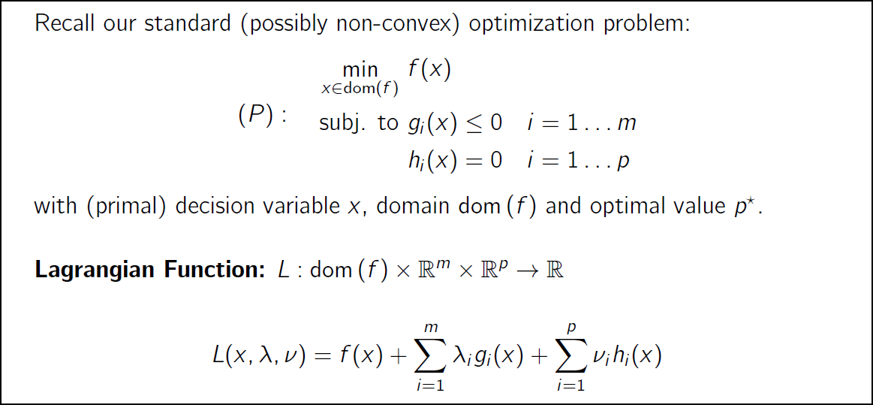

*Lagrangian is a weighted sum of the objective and constraint functions.*

## Dual Function

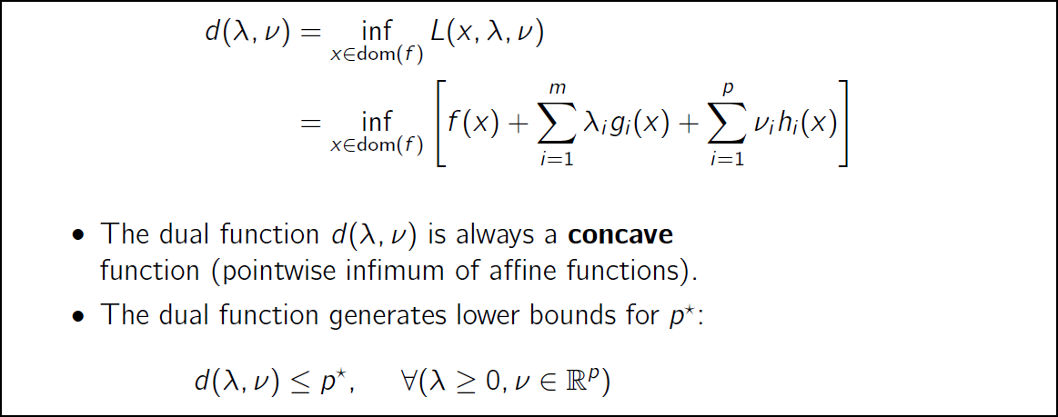

## Primal and Dual Problem

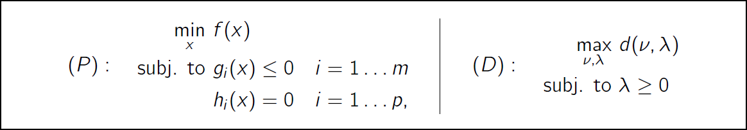

*The dual of a LP is also a LP, and the dual of a QP is also a QP.*

**Properties**

* The dual problem is convex even if the primal problem is not.
* The dual problem has an optimal value $d^{*}≤p^{*}$.
* The point $\left(λ,ν\right)$ is dual feasible if $λ≥0$ and $\left(λ,v\right)∈domain\left(d\right)$.

## Slater Condition

If there is at least one strictly feasible point for **convex problem**, then $p^{*}=d^{*}$.

## KKT Conditions

**General Optimization Problem: Necessary**

**Convex Optimization Problem: Necessary and Sufficient**

## Complementary Slackness

## Perturbed Optimization Problem and Dual

*We assume strong duality for the unperturbed problem. We don’t know if strong duality holds for the perturbed problem.*

## Weak Duality

$$p^{*}\left(u,v\right)≥d^{*}\left(ν^{*},λ^{*}\right)-u^{⊤}λ^{*}-v^{⊤}ν^{*} \\ =p^{*}\left(0,0\right)-u^{⊤}λ^{*}-v^{⊤}ν^{*}$$

## Sensitivity

$$λ_{i}^{*}=-\frac{∂p^{*}\left(0,0\right)}{∂u_{i}} \\ ν_{i}^{*}=-\frac{∂p^{*}\left(0,0\right)}{∂v_{i}}$$

## Dual of LP

|  |  |
| --- | --- |
| $$\min_{x}{c^{⊤}x}$$ $$Ax≤b \\ Cx≤e$$ | $$\max_{λ,ν}{-b^{⊤}ν-e^{⊤}λ}$$ $$A^{⊤}ν+C^{⊤}λ+c=0 \\ λ≥0$$ |

**Dual Function**

$$d\left(λ,ν\right)=\left\{\begin{matrix}-b^{⊤}ν-e^{⊤}λ & A^{⊤}ν+C^{⊤}λ+c=0 \\ -∞ & otherwise\end{matrix}\right.$$

## Dual of QP

|  |  |
| --- | --- |
| $$\min_{x}{\frac{1}{2}x^{⊤}Qx+c^{⊤}x}$$ $$Cx≤e$$ | $$\min_{λ,ν}{\frac{1}{2}λ^{⊤}CQ^{-1}C^{⊤}λ+{\left(CQ^{-1}c+e\right)}^{⊤}λ+\frac{1}{2}c^{⊤}Q^{-1}c}$$ $$λ≥0$$ |

**Dual Function**

$$d\left(λ,ν\right)=-\frac{1}{2}{（c+C^{⊤}λ）}^{⊤}Q^{-1}\left(c+C^{⊤}λ\right)-e^{⊤}λ$$

# Chapter 4 Constrained Finite Time Optimal Control

## Initial Feasible Set

*Initial feasible sets are independent of the cost.*

## General Feasible Set

## Unconstrained Solution

For unconstrained system, we have time-varying linear control law. If the prediction horizon goes to infinity, the control law will be time invariant.

## QP Constructions without Substitution (Sparse Matrix)

## QP Constructions with Substitution (Dense Matrix)

## Multiparametric Quadratic Programming

## Epigraph Formulation

**Key Idea**

|  |  |  |
| --- | --- | --- |
|  |  |  |

## LP Constructions

**Construction**

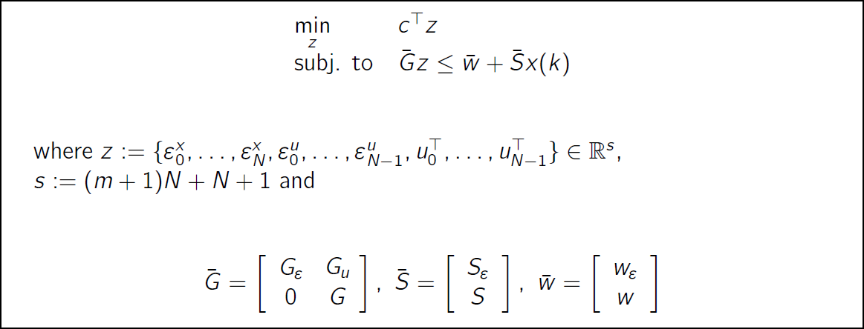

## Multi-Parametric Linear Program

## Solution Property

Quadratic cost solution is either

* unique and in the interior of feasible set –> no constraints active
* unique and on the boundary of feasible set –> at least $1$ active constraint

Linear cost solution is either

* unbounded
* unique at a vertex of the feasible set –> at least $n$ active constraints
* a set of multiple optima –> at least $1$ active constraint

*For quadratic programming, if $H≥0$, the ellipsoid may collapse to a line and the solution thus will not be optimal.*

# Chapter 5 Invariance

## Positive Invariant Set

## Maximal Positive Invariant Set

## Pre Set

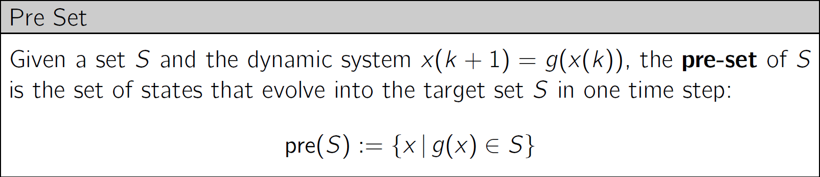

## Geometric Condition for Invariance

## Algorithm

## Control Invariant Set

## Maximal Control Invariant Set

*The maximum control invariant set is the best any controller can do.*

## Lemma: Invariant Set from Lyapunov Function

## Maximal Ellipsoidal Invariant Sets

$$F_{i}x≤f_{i}$$

$$α^{*}=\min_{i∈\left\{1,⋯,n\right\}}{\frac{f_{i}^{2}}{F_{i}P^{-1}F_{i}^{⊤}}}$$

# Chapter 6 Feasibility and Stability

Feasibility and stability are function of tuning.

The horizon can have a strong impact on the region of attraction.

## Infinite-Horizon

If we solve the RHC problem for $N =∞$ (as done for LQR), then the open loop trajectories are the same as the closed loop trajectories. Hence

* If problem is feasible, the closed loop trajectories will be always feasible
* If the cost is finite, then states and inputs will converge asymptotically to $0$.

## Zero Terminal State Constraint

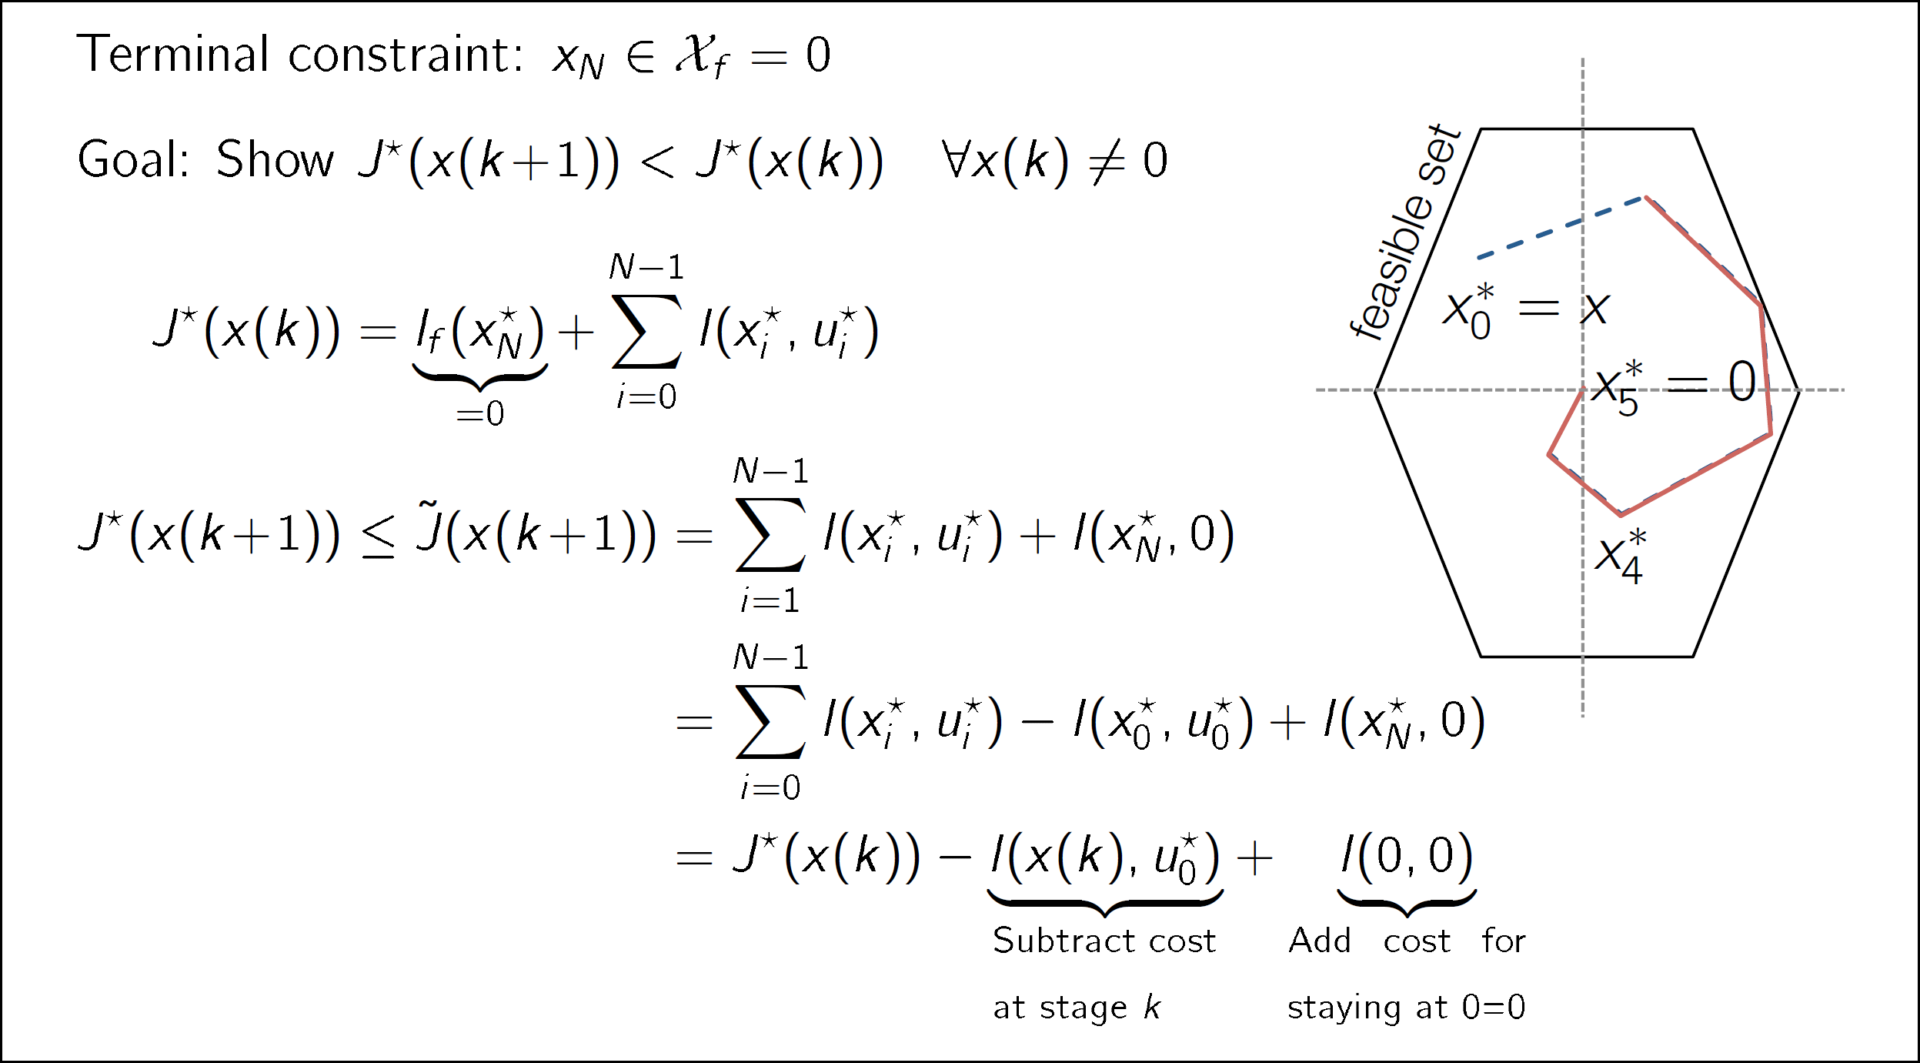

## Theorem: Stability

Under **Stability Assumptions**, the following theorem holds.

## Terminal Set Constraint

## Choice of Terminal Set

*Above ideas apply to non-linear systems.*

# Chapter 7 Practical Issues

## Steady State Tracking

$$x_{s}=Ax_{s}+Bu_{s} \\ z_{s}=Hx_{s}=r \\ \left[\begin{aligned}0 \\ r\end{aligned}\right]=\left[\begin{matrix}A-I & B \\ H & 0\end{matrix}\right]\left[\begin{matrix}x_{s} \\ u_{s}\end{matrix}\right]$$

*In case of multiple solution, compute the cheapest steady state:*

$$\min{u_{s}^{⊤}Ru_{s}}$$

*If no solution exists, compute the closest reachable set point:*

$${\min_{x_{s}}\left(Hx_{s}-r\right)}^{⊤}Q_{s}\left(Hx_{s}-r\right)$$

## MPC Tracking Formulation

$${\min_{U}\left\|z_{N}-Hx_{s}\right\|}_{P_{z}}^{2}+\sum_{i=0}^{N-1}{{\left\|z_{i}-Hx_{s}\right\|}_{Q_{z}}^{2}+{\left\|u_{i}-u_{s}\right\|}_{R}^{2}}$$

## Convergence

## Offset-Free Tracking

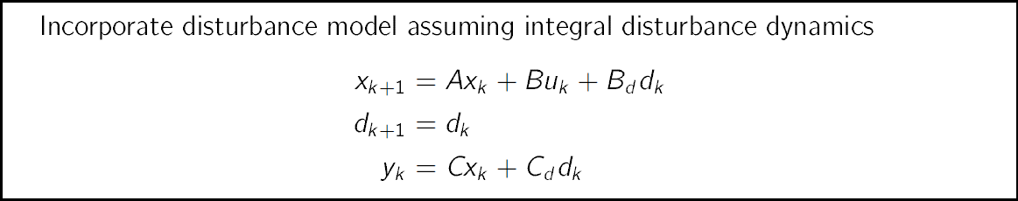

*Intuition: at steady state and given $y_{s}$, $d_{S}$ must be uniquely defined.*

## Soft Constraints

If the original problem is feasible, then the softened problem should have the same solution. Soft constraints recovers feasibility when constraintes cannot be met.

*Standard methods for soft constrained MPC do not provide a stability guarantee for open-loop unstable systems.*

## Linear State Estimation

*Observer output $C{\hat{x}}_{∞}+C_{d}{\hat{d}}_{∞}$ tracks the measurement $y_{∞}$ without offset.*

## Offset-Free Tracking Algorithm

* Estimate state and disturbance $\hat{x}$ and $\hat{d}$
* Obtain $\left(x_{s},u_{s}\right)$ from steady-state target problem using disturbance estimate $\hat{d}$
* Solve MPC problem for tracking using disturbance estimate $\hat{d}$

## MPC without Terminal Set

We can remove terminal constraint while maintaining stability if

* initial state lies in sufficiently small subset of feasible set
* $N$ is sufficiently large

such that terminal state satisfies terminal constraint without explicitly enforcing it in the optimization.

*A feasible set without terminal constraint is not invariant.*

*Terminal constraints reduce the feasible set.*

# Chapter 8 Robust MPC

## Uncertain Constrained System

*Uncertain evolution is the nominal system plus offset caused by the disturbance.*

## Robust Positive Invariant Set

## Robust Pre Set

## Geometric Condition for Robust Invariance

## Minkowski Sum

## Pontryagin Difference

## Robust Open-Loop MPC

*If we have an invariant set $X_{f}⊆X$ and $κ\left(X_{f}\right)⊆U$, then it provides a set of initial states from which the trajectory will never violate the system constraints if we apply the controller $κ$.*

## Robust Invariance

# Chapter 9 Tube MPC

## Control Law

$$u_{i}=K\left(x_{i}-z_{i}\right)+v_{i}$$

## Error Dynamics

## Minimal Robust Invariant Set

## Tube MPC Formulation

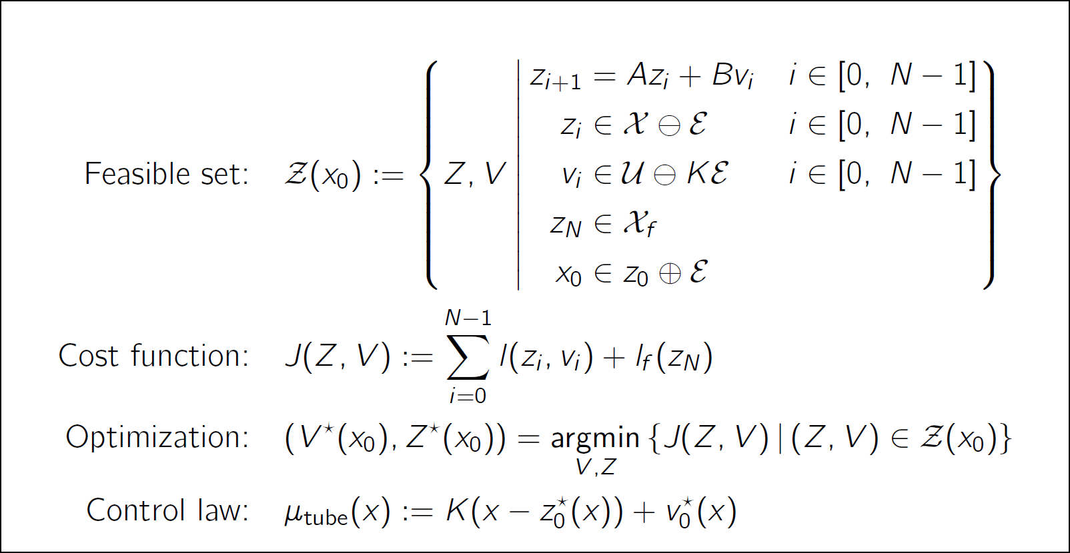

$x$*is the measured state and $z_{0}^{*}$ is the estimation of nominal state.*

$X_{f}$*is defined for the nominal system.*

**CHECK $X_{f}⊆X⊖E$ AND $KX_{f}⊆U⊖KE$!**

## Tube MPC Stability Assumptions

* Stage cost is positive definite, i.e. it is strictly positive and only zero at origin.
* The terminal set is invariant for the **nominal system** under the local control law $κ_{f}\left(z\right)$:

$$Az+Bκ_{f}\left(z\right)∈X_{f}, ∀z∈X_{f}$$

All **tightened state and input constraints** are satisfied in $X_{f}$:

$$X_{f}⊆X⊖E, κ_{f}\left(z\right)∈U⊖KE, ∀z∈X_{f}$$

* Terminal cost is continuous Lyapunov function in $X_{f}$ and satisfies:

$$l_{f}\left(Az+Bκ_{f}\left(z\right)\right)-l_{f}\left(z\right)≤-l\left(z,κ_{f}\left(z\right)\right), ∀z∈X_{f}$$

## Robust Invariance of Tube MPC

## Robust Stability

# Chapter 10 Nominal MPC with Noise

## Input-to-State Stability

# Miscellaneous

Discrete State: $x\left(k\right)=x^{c}\left(kT_{s}\right)$

Predicted State: $x_{0},⋯x_{k}$

Actual State: $x\left(0\right),⋯,x\left(k\right)$

Gaussian Distribution: $\sim N\left(μ,σ^{2}\right)$

$$z⊕E⊆X ⇐ z∈X⊖E$$

$$u∈KE⊕v⊂U ⇔ v∈U⊖KE$$

# Impact of Horizon

* (LQR) Increase in the horizon length does not necessarily guarantee stability.
* (MPC) Decrease in the prediction horizon can cause loss of the stability.
* (MPC) Inclusion of terminal cost and constraint provides stability.
* For short horizons, the balance between the cost of the state trajectory and the input trajectory comes down in favor of the input, since the state doesn’t move “too much” over the short term if no input action is taken. Over a longer horizon, the cost of the state trajectory will dominate, causing the input to take action to decrease it.
* Given a horizon length $N^{*}$ that leads to convergence of the closed-loop system, the system is not guaranteed to converge for $N>N^{*}$.
* The horizon can have a strong impact on the region of attraction.
* With larger horizon length $N$, RoA approaches maximum control invariant set.

# Rank and Solution

|  |  |  |  |
| --- | --- | --- | --- |
| $$Ax=b$$ | $$rank\left(A\right)=r$$ | $$A=A_{m×n}$$ | $$b=b_{m×1}$$ |
| $$r=m=n$$ $1$ Solution | $$r=n<m$$ $0$ or $1$ Solution | $$r=m<n$$ $∞$ Solution | $$r<m, r<n$$ $0$ or $∞$ Solution |